General Chemistry 2 | 3rd Quarter
WW6: Hess’ Law
January 21 2021

Find ΔH.
Given:
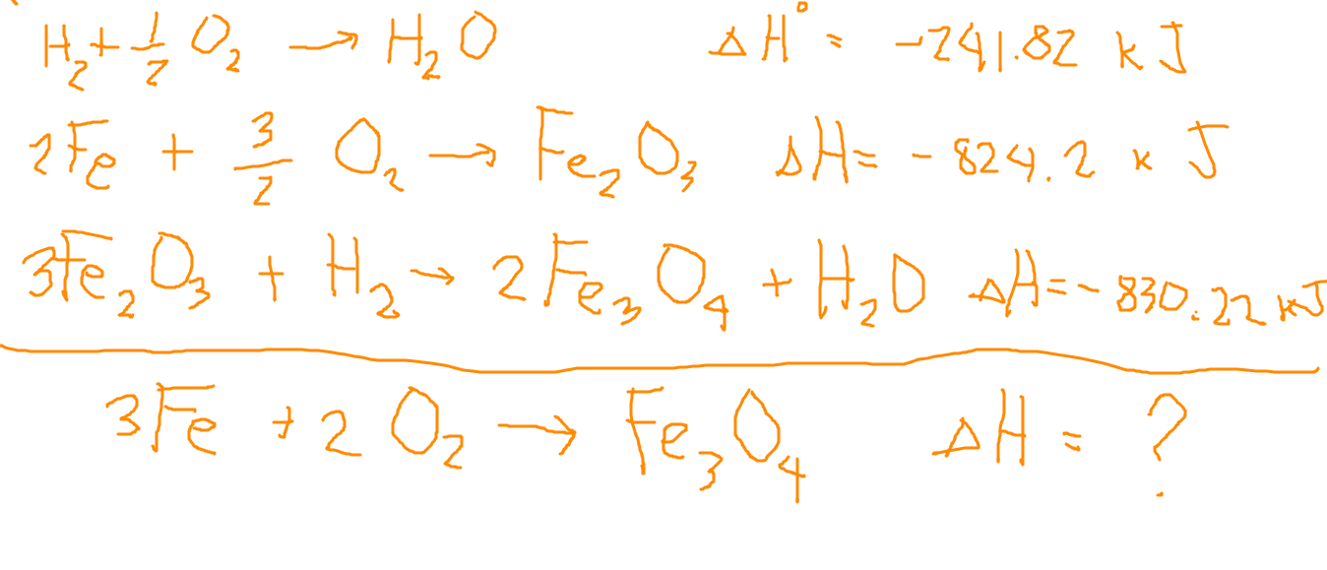

- 1/2 | (½)H₂O → (½)H₂ + (¼)O₂ | ΔH = -241.82 kJ * - ½ = 120.91 kJ
3/2 | 3Fe + (9/4)O₂ → (3/2)Fe₂O₃ | ΔH = -824.2 kJ * 3/2 = -1236.3 kJ
1/2 | (3/2)Fe₂O₃ + (½)H₂ →Fe₃O₄ + (½)H₂O | ΔH = -830.22kJ * ½ = -415.11 kJ
 | 3Fe + 2O₂ → Fe₃O₄ | ΔH = -1530.5 kJ

